Приложение 1

**СХЕМА ГРАНИЦ РАЗМЕЩЕНИЯ ПУБЛИЧНОГО СЕРВИТУТА**

Объект:ВЛ-0,4 кВ Л-1 от КТП Стрелка-3

Местоположение:Новгородская обл., Новгородский р-н, Трубичинское сельское поселение, д.Стрелка

Кадастровый квартал: 53:11:1900305

Кадастровые номера земельных участков: 53:11:0000000:6713, 53:11:1900305:17, 53:11:1900305:30, 53:11:1900305:38, 53:11:1900305:64, 53:11:1900305:66, 53:11:1900305:143, 53:11:1900305:145, 53:11:1900305:218, 53:11:1900305:222, 53:11:1900305:227, 53:11:1900305:233, 53:11:1900305:247, 53:11:1900305:258, 53:11:1900305:284, 53:11:1900305:359, 53:11:1900305:369, 53:11:1900305:378, 53:11:1900305:387, 53:11:1900305:407, 53:11:1900305:485, 53:11:1900305:489, 53:11:1900305:492, 53:11:1900305:522, 53:11:1900305:531, 53:11:1900305:544, 53:11:1900305:563, 53:11:1900305:564, 53:11:1900305:717, 53:11:1900305:721, 53:11:1900305:818, 53:11:1900305:1089, 53:11:1900305:1157, 53:11:1900306:56, 53:11:1900306:143

Система координат:МСК-53 (Зона2)

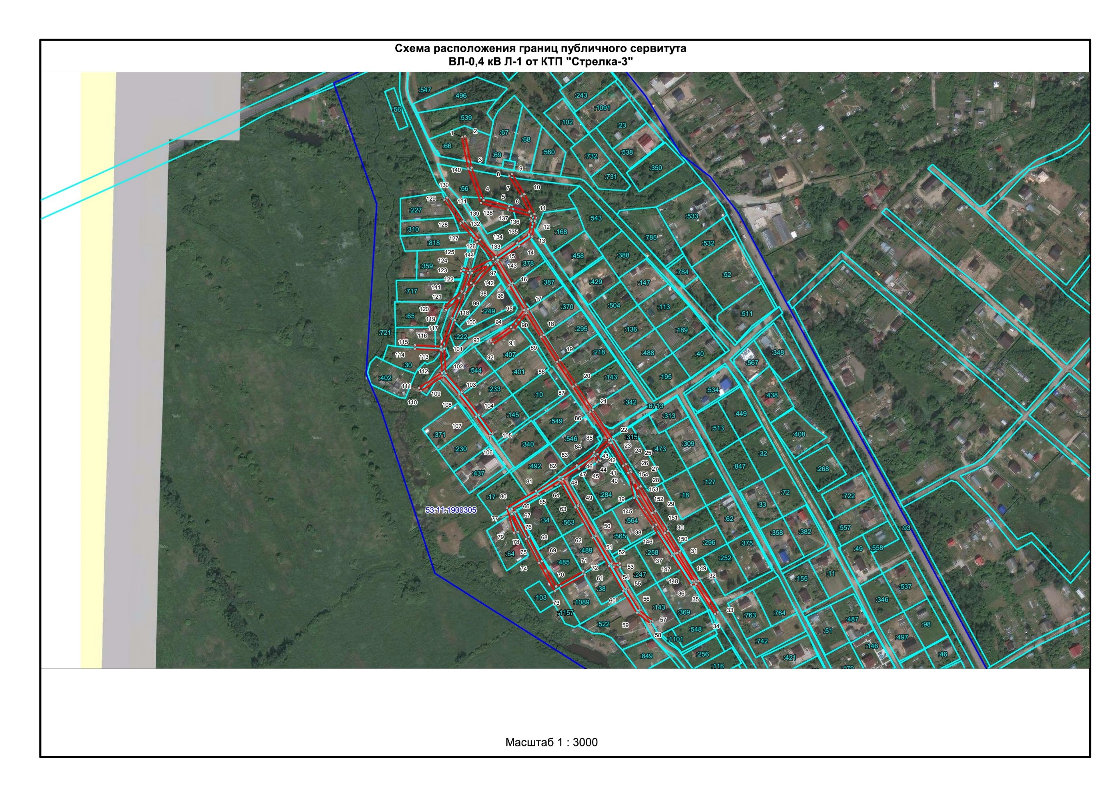Площадьсервитута: 7567 кв.м

**Масштаб 1:3300**

|  |  |
| --- | --- |
|  | Граница публичного сервитута |
| 53:11:1900305 | Граница и кадастровый номер кадастрового квартала |
| :6713 | Граница и обозначение земельного участка, сведения о котором внесены в ЕГРН |

**Используемые условные знаки и обозначения:**

|  |  |  |  |
| --- | --- | --- | --- |
| ВЛ-0,4 кВ Л-1 от КТП Стрелка-3 | | | |
| **Номер угла** | **X, м** | **Y, м** | **Средняя квадратическая погрешность характерной точки** |
| 1 | 586382.98 | 2185499.61 | 0.10 |
| 2 | 586383.78 | 2185503.53 | 0.10 |
| 3 | 586348.43 | 2185510.70 | 0.10 |
| 4 | 586311.78 | 2185524.28 | 0.10 |
| 5 | 586305.05 | 2185552.70 | 0.10 |
| 6 | 586298.76 | 2185575.88 | 0.10 |
| 7 | 586316.63 | 2185566.93 | 0.10 |
| 8 | 586339.40 | 2185552.85 | 0.10 |
| 9 | 586341.50 | 2185556.25 | 0.10 |
| 10 | 586318.66 | 2185570.38 | 0.10 |
| 11 | 586296.17 | 2185581.66 | 0.10 |
| 12 | 586288.50 | 2185582.15 | 0.10 |
| 13 | 586270.62 | 2185579.02 | 0.10 |
| 14 | 586260.26 | 2185564.54 | 0.10 |
| 15 | 586244.28 | 2185540.87 | 0.10 |
| 16 | 586217.80 | 2185556.95 | 0.10 |
| 17 | 586188.51 | 2185574.46 | 0.10 |
| 18 | 586159.53 | 2185592.20 | 0.10 |
| 19 | 586131.03 | 2185610.40 | 0.10 |
| 20 | 586103.44 | 2185628.67 | 0.10 |
| 21 | 586075.10 | 2185647.49 | 0.10 |
| 22 | 586041.65 | 2185669.94 | 0.10 |
| 23 | 586013.94 | 2185685.30 | 0.10 |
| 24 | 586007.61 | 2185689.35 | 0.10 |
| 25 | 586007.87 | 2185689.77 | 0.10 |
| 26 | 586005.32 | 2185691.42 | 0.10 |
| 27 | 586005.05 | 2185690.99 | 0.10 |
| 28 | 585988.56 | 2185701.56 | 0.10 |
| 29 | 585960.53 | 2185718.27 | 0.10 |
| 30 | 585938.14 | 2185732.14 | 0.10 |
| 31 | 585915.18 | 2185746.28 | 0.10 |
| 32 | 585881.68 | 2185766.89 | 0.10 |
| 33 | 585846.25 | 2185788.71 | 0.10 |
| 34 | 585844.15 | 2185785.31 | 0.10 |
| 35 | 585878.36 | 2185764.24 | 0.10 |
| 36 | 585876.99 | 2185758.19 | 0.10 |
| 37 | 585910.40 | 2185736.47 | 0.10 |
| 38 | 585943.02 | 2185715.40 | 0.10 |
| 39 | 585975.69 | 2185694.26 | 0.10 |
| 40 | 586003.45 | 2185687.27 | 0.10 |
| 41 | 586011.94 | 2185681.83 | 0.10 |
| 42 | 586037.46 | 2185667.70 | 0.10 |
| 43 | 586025.05 | 2185652.80 | 0.10 |
| 44 | 586017.47 | 2185656.05 | 0.10 |
| 45 | 586015.89 | 2185652.37 | 0.10 |
| 46 | 586022.47 | 2185649.55 | 0.10 |
| 47 | 586008.81 | 2185631.88 | 0.10 |
| 48 | 585997.03 | 2185613.58 | 0.10 |
| 49 | 585966.81 | 2185631.10 | 0.10 |
| 50 | 585932.65 | 2185650.66 | 0.10 |
| 51 | 585901.39 | 2185668.59 | 0.10 |
| 52 | 585901.50 | 2185678.00 | 0.10 |
| 53 | 585897.49 | 2185678.03 | 0.10 |
| 54 | 585897.42 | 2185670.85 | 0.10 |
| 55 | 585872.09 | 2185685.29 | 0.10 |
| 56 | 585848.41 | 2185700.01 | 0.10 |
| 57 | 585836.79 | 2185715.10 | 0.10 |
| 58 | 585833.63 | 2185712.66 | 0.10 |
| 59 | 585845.70 | 2185696.98 | 0.10 |
| 60 | 585870.08 | 2185681.83 | 0.10 |
| 61 | 585898.38 | 2185665.70 | 0.10 |
| 62 | 585930.66 | 2185647.19 | 0.10 |
| 63 | 585964.81 | 2185627.64 | 0.10 |
| 64 | 585994.90 | 2185610.19 | 0.10 |
| 65 | 585979.73 | 2185585.44 | 0.10 |
| 66 | 585963.10 | 2185556.28 | 0.10 |
| 67 | 585959.69 | 2185560.15 | 0.10 |
| 68 | 585931.12 | 2185575.80 | 0.10 |
| 69 | 585904.03 | 2185590.08 | 0.10 |
| 70 | 585875.49 | 2185606.16 | 0.10 |
| 71 | 585892.38 | 2185636.62 | 0.10 |
| 72 | 585888.88 | 2185638.56 | 0.10 |
| 73 | 585870.11 | 2185604.61 | 0.10 |
| 74 | 585902.14 | 2185586.55 | 0.10 |
| 75 | 585929.23 | 2185572.28 | 0.10 |
| 76 | 585956.92 | 2185557.24 | 0.10 |
| 77 | 585957.38 | 2185556.72 | 0.10 |
| 78 | 585937.18 | 2185562.64 | 0.10 |
| 79 | 585936.06 | 2185558.80 | 0.10 |
| 80 | 585964.44 | 2185550.47 | 0.10 |
| 81 | 585983.19 | 2185583.43 | 0.10 |
| 82 | 585999.37 | 2185609.83 | 0.10 |
| 83 | 586012.03 | 2185629.51 | 0.10 |
| 84 | 586027.19 | 2185649.12 | 0.10 |
| 85 | 586040.92 | 2185665.61 | 0.10 |
| 86 | 586072.88 | 2185644.16 | 0.10 |
| 87 | 586101.22 | 2185625.33 | 0.10 |
| 88 | 586128.86 | 2185607.03 | 0.10 |
| 89 | 586157.43 | 2185588.79 | 0.10 |
| 90 | 586183.98 | 2185572.54 | 0.10 |
| 91 | 586165.47 | 2185557.92 | 0.10 |
| 92 | 586149.11 | 2185534.53 | 0.10 |
| 93 | 586152.39 | 2185532.23 | 0.10 |
| 94 | 586168.46 | 2185555.19 | 0.10 |
| 95 | 586187.63 | 2185570.33 | 0.10 |
| 96 | 586215.73 | 2185553.53 | 0.10 |
| 97 | 586241.59 | 2185537.82 | 0.10 |
| 98 | 586215.48 | 2185513.15 | 0.10 |
| 99 | 586206.36 | 2185502.85 | 0.10 |
| 100 | 586176.78 | 2185491.94 | 0.10 |
| 101 | 586144.09 | 2185479.81 | 0.10 |
| 102 | 586116.45 | 2185481.47 | 0.10 |
| 103 | 586094.87 | 2185499.58 | 0.10 |
| 104 | 586069.49 | 2185519.12 | 0.10 |
| 105 | 586048.07 | 2185534.37 | 0.10 |
| 106 | 586045.75 | 2185531.11 | 0.10 |
| 107 | 586067.14 | 2185515.88 | 0.10 |
| 108 | 586092.33 | 2185496.49 | 0.10 |
| 109 | 586113.03 | 2185479.12 | 0.10 |
| 110 | 586096.17 | 2185453.15 | 0.10 |
| 111 | 586099.53 | 2185450.97 | 0.10 |
| 112 | 586116.71 | 2185477.44 | 0.10 |
| 113 | 586142.48 | 2185475.90 | 0.10 |
| 114 | 586143.85 | 2185446.47 | 0.10 |
| 115 | 586147.85 | 2185446.65 | 0.10 |
| 116 | 586146.46 | 2185476.42 | 0.10 |
| 117 | 586178.16 | 2185488.18 | 0.10 |
| 118 | 586200.77 | 2185496.53 | 0.10 |
| 119 | 586187.61 | 2185481.62 | 0.10 |
| 120 | 586190.61 | 2185478.98 | 0.10 |
| 121 | 586208.70 | 2185499.45 | 0.10 |
| 122 | 586229.38 | 2185506.75 | 0.10 |
| 123 | 586231.83 | 2185498.53 | 0.10 |
| 124 | 586235.67 | 2185499.67 | 0.10 |
| 125 | 586232.83 | 2185509.15 | 0.10 |
| 126 | 586245.48 | 2185534.87 | 0.10 |
| 127 | 586264.66 | 2185516.97 | 0.10 |
| 128 | 586285.44 | 2185498.14 | 0.10 |
| 129 | 586312.45 | 2185479.83 | 0.10 |
| 130 | 586314.69 | 2185483.15 | 0.10 |
| 131 | 586287.80 | 2185501.38 | 0.10 |
| 132 | 586267.35 | 2185519.92 | 0.10 |
| 133 | 586247.48 | 2185538.47 | 0.10 |
| 134 | 586263.56 | 2185562.28 | 0.10 |
| 135 | 586272.93 | 2185575.36 | 0.10 |
| 136 | 586288.61 | 2185578.14 | 0.10 |
| 137 | 586294.10 | 2185577.77 | 0.10 |
| 138 | 586301.16 | 2185551.75 | 0.10 |
| 139 | 586308.41 | 2185521.25 | 0.10 |
| 140 | 586347.48 | 2185506.81 | 0.10 |
| 1 | 586382.98 | 2185499.61 | 0.10 |
| 141 | 586214.16 | 2185505.63 | 0.10 |
| 142 | 586218.29 | 2185510.31 | 0.10 |
| 143 | 586238.18 | 2185529.10 | 0.10 |
| 144 | 586229.26 | 2185510.95 | 0.10 |
| 141 | 586214.16 | 2185505.63 | 0.10 |
| 145 | 585977.27 | 2185697.98 | 0.10 |
| 146 | 585945.20 | 2185718.76 | 0.10 |
| 147 | 585912.58 | 2185739.83 | 0.10 |
| 148 | 585881.49 | 2185760.02 | 0.10 |
| 149 | 585881.95 | 2185762.03 | 0.10 |
| 150 | 585913.08 | 2185742.88 | 0.10 |
| 151 | 585936.04 | 2185728.74 | 0.10 |
| 152 | 585958.47 | 2185714.84 | 0.10 |
| 153 | 585986.43 | 2185698.18 | 0.10 |
| 154 | 585992.86 | 2185694.06 | 0.10 |
| 145 | 585977.27 | 2185697.98 | 0.10 |